**Project Design Phase**

**Problem - Solution Fit Template**

| Date | 27 JUNE 2025 |
| --- | --- |
| Team ID | NM2025TMID00377 |
| Project Name | Calculating Family Expenses using ServiceNow |
| Maximum Marks | 2 Marks |

### Problem – Solution Fit

The project **“Calculating Family Expenses using ServiceNow”** aims to solve the challenges families face in manually tracking and managing their finances. Traditional methods are time-consuming, prone to mistakes, and lack a clear financial overview. By automating expense recording, categorization, and reporting within ServiceNow, the solution ensures accuracy, saves time, and offers valuable insights for better financial planning.

### Purpose

* To address a persistent challenge in family finance management by offering a structured and automated way to handle expenses.
* To design a solution that fits naturally into users’ existing spending and tracking habits, ensuring quick adoption and ease of use.
* To enhance user experience through clear communication, intuitive design, and a strong focus on real financial pain points.
* To build reliability and confidence among users by delivering consistent, precise, and time-saving functionalities.
* To analyze the limitations of traditional expense tracking methods and develop a modern digital platform that simplifies and enhances financial control.

**Template:**

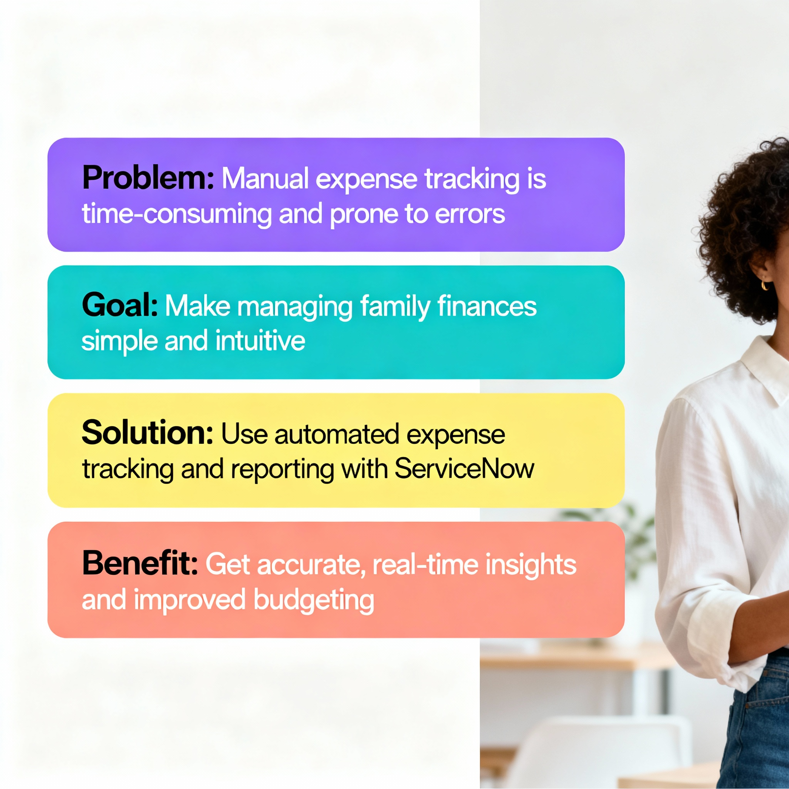

The project **“Calculating Family Expenses using ServiceNow”** focuses on solving the everyday struggle families face when managing their financial records manually. Traditional methods of tracking daily, monthly, or yearly expenses are not only time-consuming but also prone to errors and lack a unified view of overall spending and budgeting trends.

To eliminate these issues, the project introduces an **intelligent expense management solution** built on the **ServiceNow platform**. This system enables users to seamlessly log their expenses, group them into relevant categories, and generate real-time analytical reports. With automated calculations and interactive dashboards, it delivers accurate insights into financial behavior and spending patterns.

By integrating ServiceNow’s powerful features such as workflow automation, analytics, and secure data handling, this solution provides a **streamlined, dependable, and scalable approach** to modern family expense management — helping households plan smarter and maintain better financial discipline.